**M.Sc. Computer Science**

**Semester III**

**E-Commerce**

**Full-Stack Web Development Project**

**Rohini Singh (36)**

**1. URL of Github Directory for E-Commerce Project**  https://github.com/Rohini0209/E-commerce.git

**2. E-Commerce Project Proposal:**

**Wooden dots**- **Platform for home décor items and furniture** Wooden dots is a B2C E-commerce service website that focuses on selling not only furniture, but also emphasis on home décor and interior. It aims to bring alive the aesthetics of your home, giving it an elegant look and luxurious feel. Wooden dots is a platform where consumer can get expert assistance and suggestions. They can get the interiors of their home designed by wooden dot’s experts.

**Features -**

**(i) Must have**

- Register/login Customer

- Explore Products

- Add to Cart

- Profile Status

- Billing(cod/Credit Card-Visa or Mastercard/Debit Card) - Print or Share transaction

**(ii)Good to have**

- Quick home décor ideas

- Streaming Videos for coloration and arrangement tips - Home décor Blog

- Appointments with the Experts

- Personalized recommendations

**3. Database schema :**

There will be three tables : Users, Product-Categories, Products

Their Description is as following -

**Users**

- user_id *(Type - int primary key )*

- user_name *(Type - varchar , Length - 255 )*

- password *(Type - varchar , Length - 255 )*

- contact number *(Type - varchar , Length - 10)*

- e-mail *(Type - varchar , Length - 255 )*

- address *(Type - varchar , Length - 255 )*

**Product-Categories**

- category_id *(Type - int primary key )*

- category_name *(Type - varchar , Length - 255 )*

- status *(Type - tinyint )*

**Products**

- product_id *(Type - int primary key )*

- product_name *(Type - varchar , Length - 255 )*

- categories-id *(Type - int )*

- mrp *(Type - float )*

- price *(Type - float )*

- qty *(Type - int)*

- image*(Type - varchar , Length - 255 )*

- short_desc *(Type - varchar , Length - 2000 )*

- description *(Type - text)*

- status *(Type - tinyint)*

**4. APIs(both request and response)to be developed for accessing the DB:**

***Fetch:***

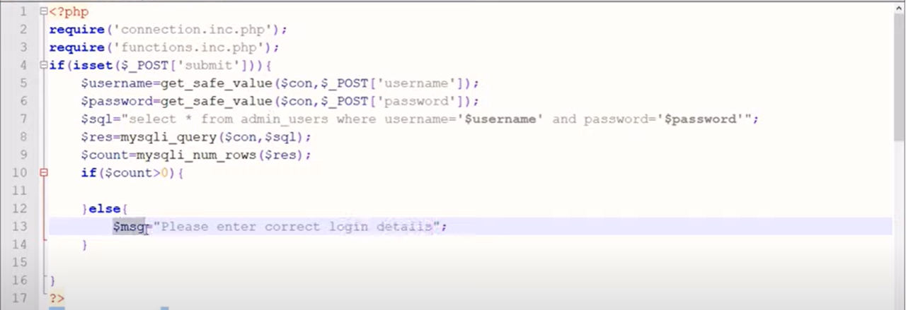

***Delete:***

***Store:***

***Modify:***

